Assignment #7 – jQuery (Selectors, Effects, Animations)
Name: Amina Urazbekova
Group: MT-2406

Part 1 – Getting Started with jQuery

Task 0 – Setup
Here, I included jQuery from the official CDN and wrote a $(document).ready() function to check that it works properly.
When the page loads, the message “jQuery is ready!” appears in the browser console.
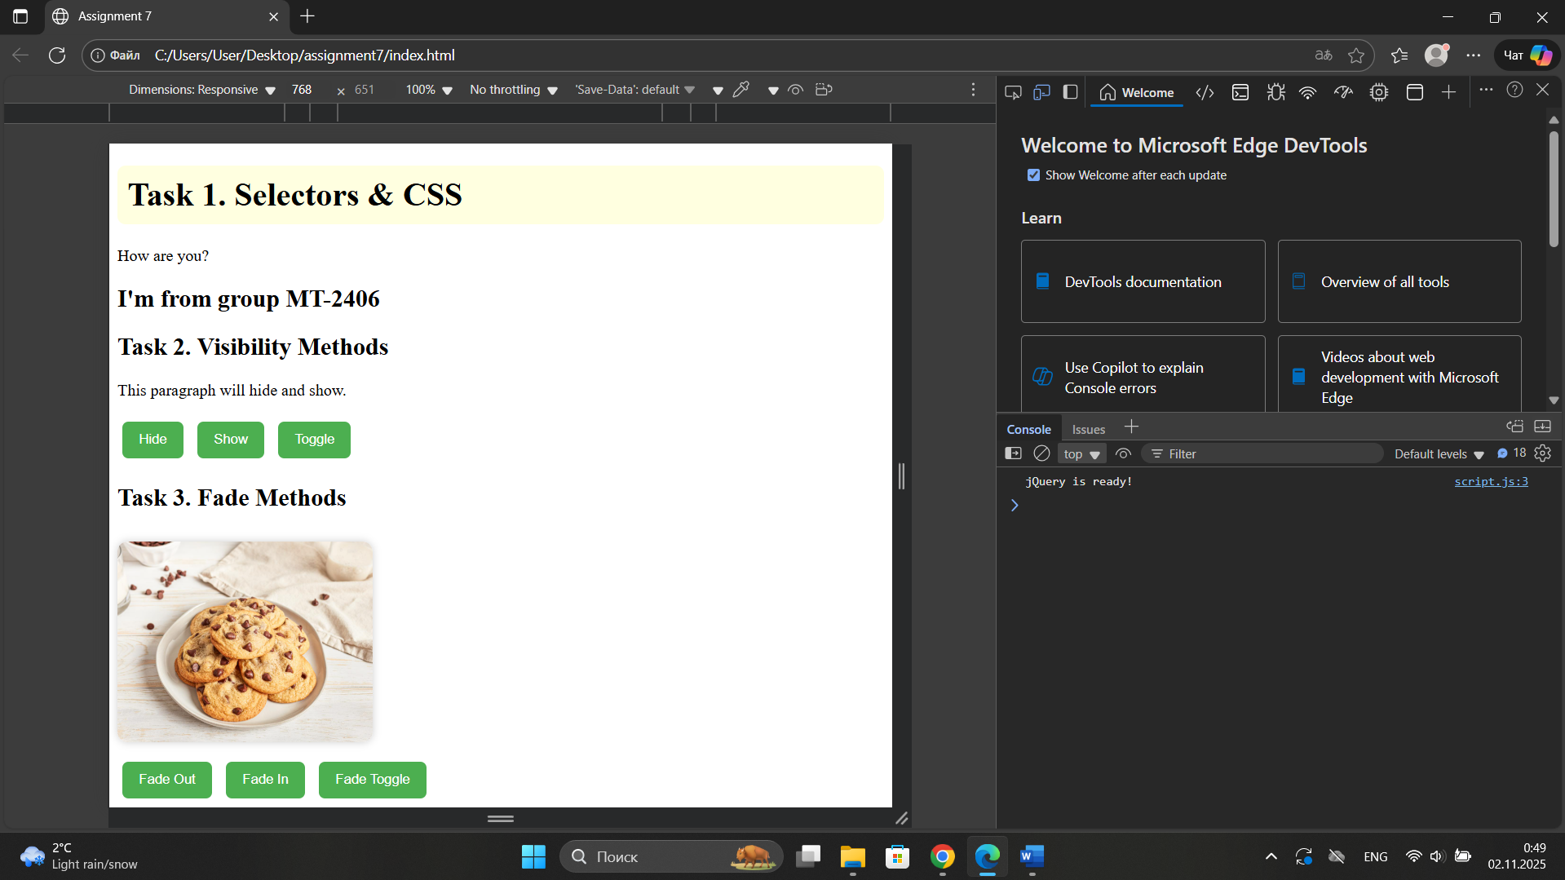

Task 1 – Selectors & CSS
I used three different jQuery selectors and methods to manipulate page elements: id selector with .text() to change the text inside a paragraph, class selector with .html() to replace content using HTML tags, tag selector with .css() to style an element dynamically. This shows how jQuery can quickly change content and styles on my webpage.

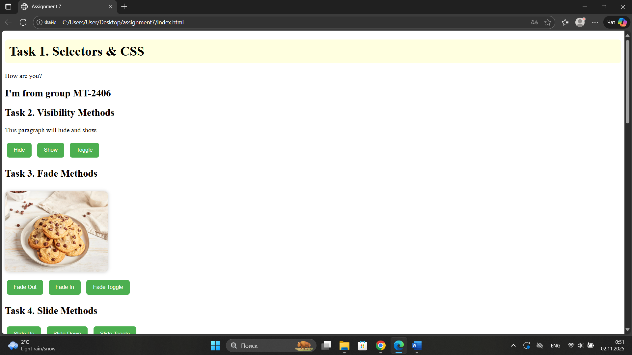

Part 2 – jQuery Effects

Task 2 – Visibility Methods
I created a paragraph and three buttons: Hide, Show, and Toggle. By using .hide(), .show(), and .toggle(), I made the paragraph appear and disappear when I click the buttons.
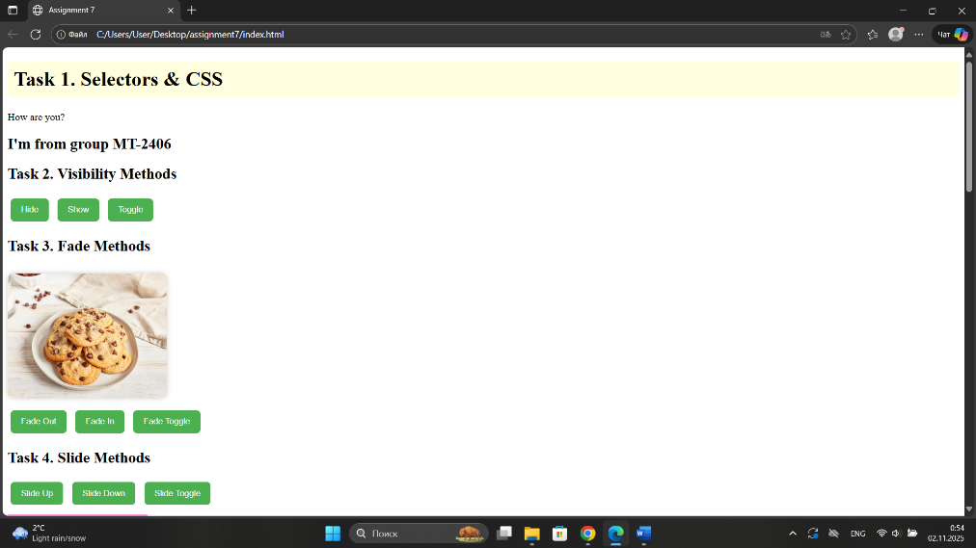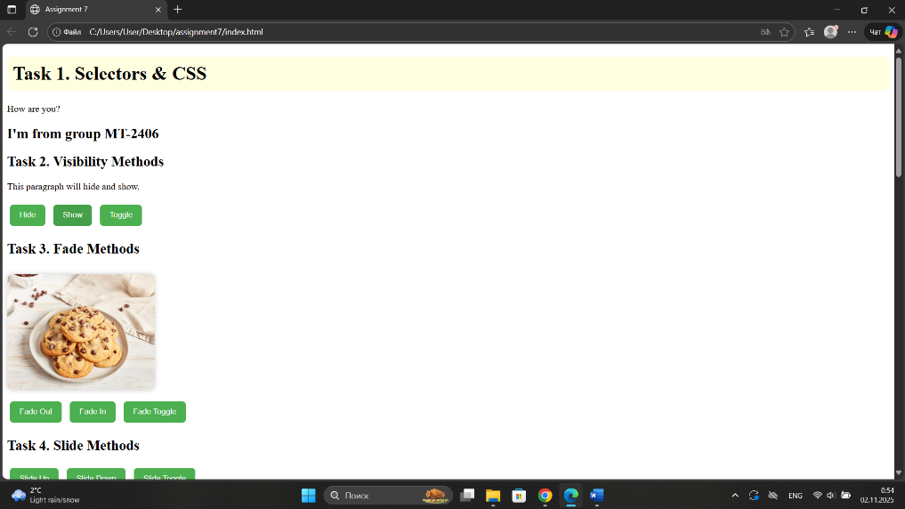

Task 3 – Fade Methods
I added an image and used .fadeIn(), .fadeOut(), and .fadeToggle() to smoothly show or hide it.
This shows how jQuery creates transition effects for visual changes.
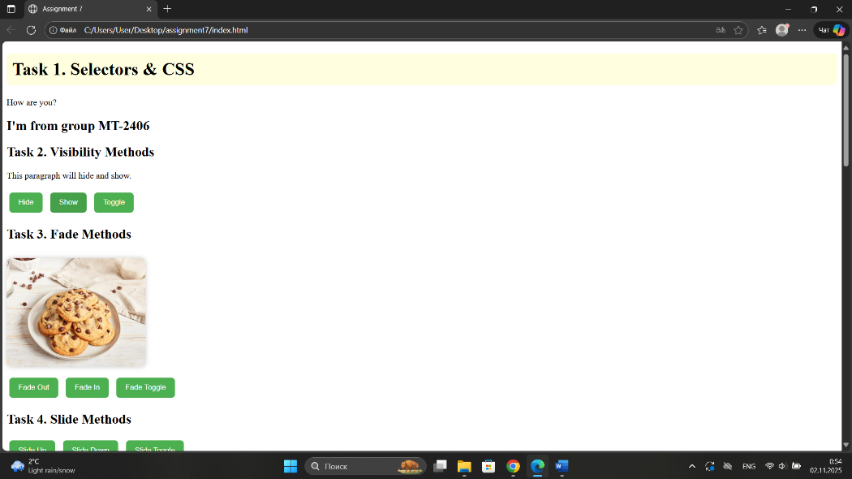
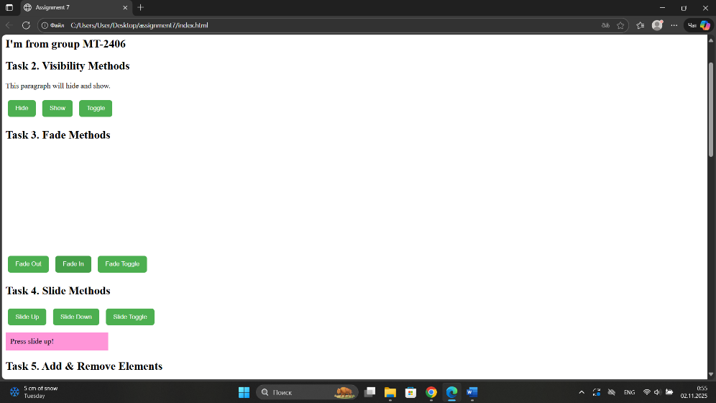

Task 4 – Slide Methods
I created a collapsible panel with three buttons to control it using .slideUp(), .slideDown(), and .slideToggle(). This allowed me to open and close the panel smoothly with animations.
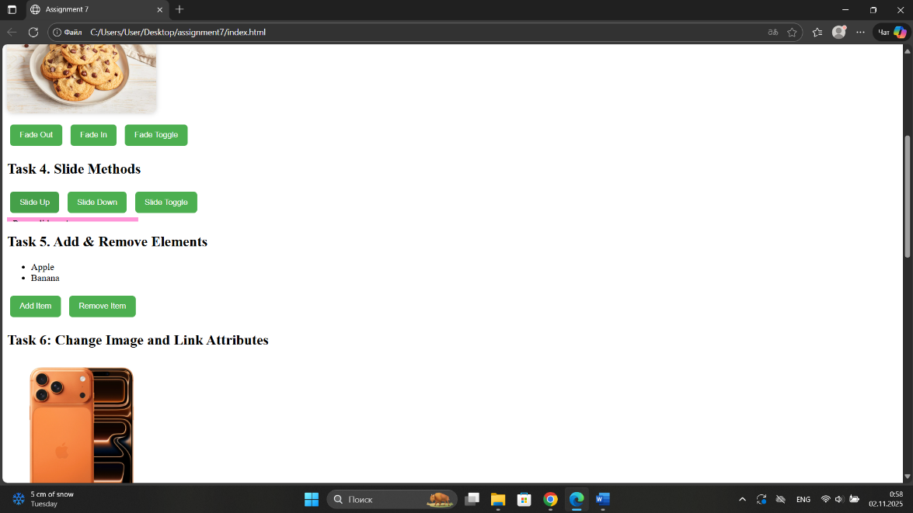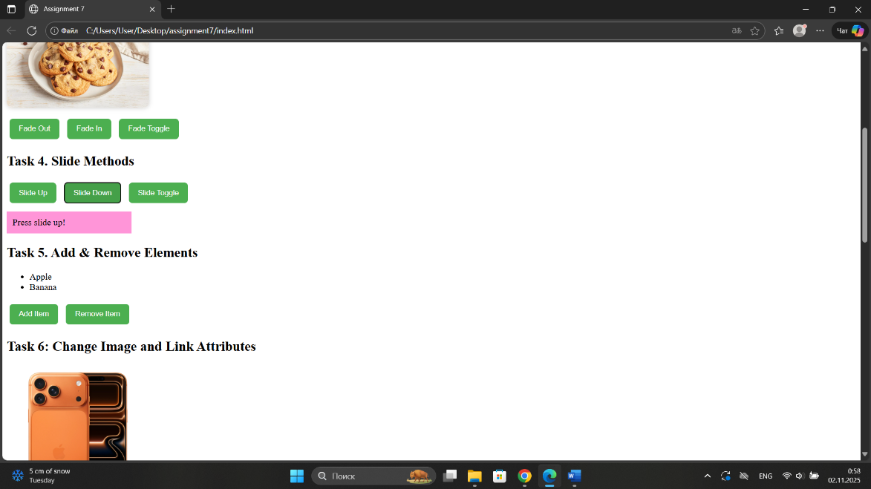

Part 3 – DOM Manipulation

Task 5 – Add & Remove Elements
I made a list that allows items to be added or removed using buttons. The .append() method adds new list items, and with .remove() deletes the last one.
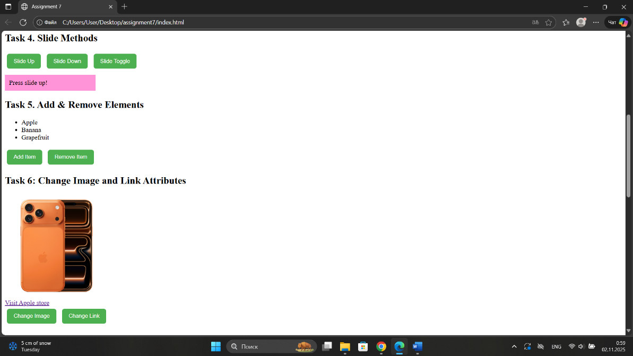

Task 6 – Modifying Attributes
I used .attr() to change an image’s src and a hyperlink’s href. By clicking buttons, both the image and link update without reloading the page.

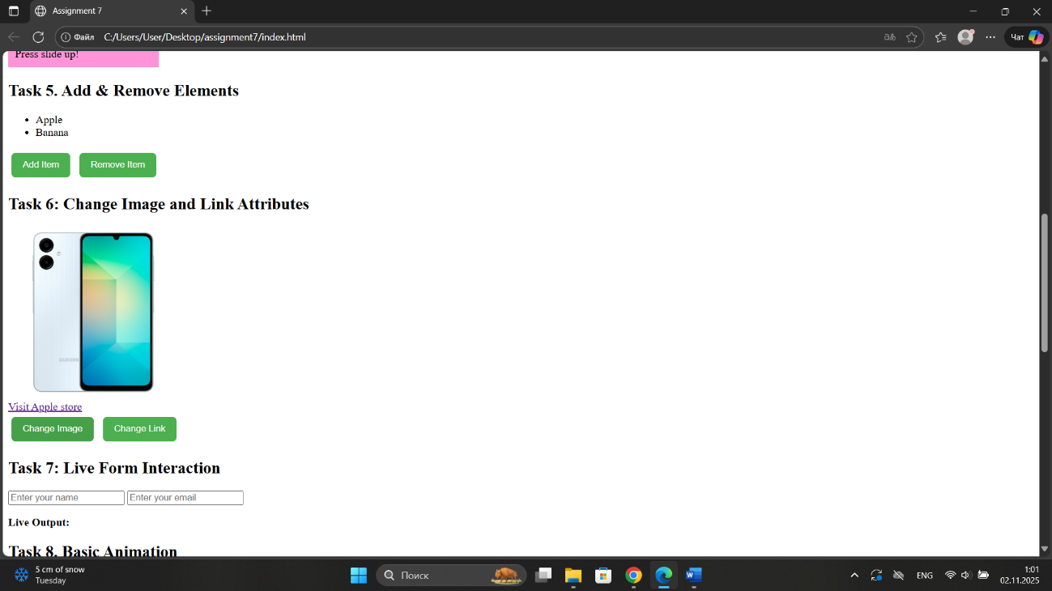

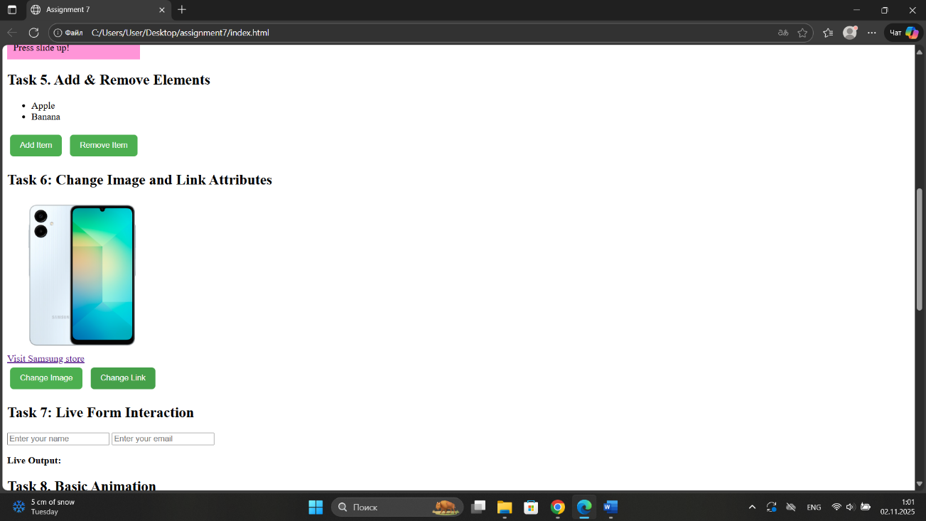

Task 7 – Form Interaction
I created a form with input fields for Name and Email. By using .val() and .text(), the user’s input appears live below the form while typing.
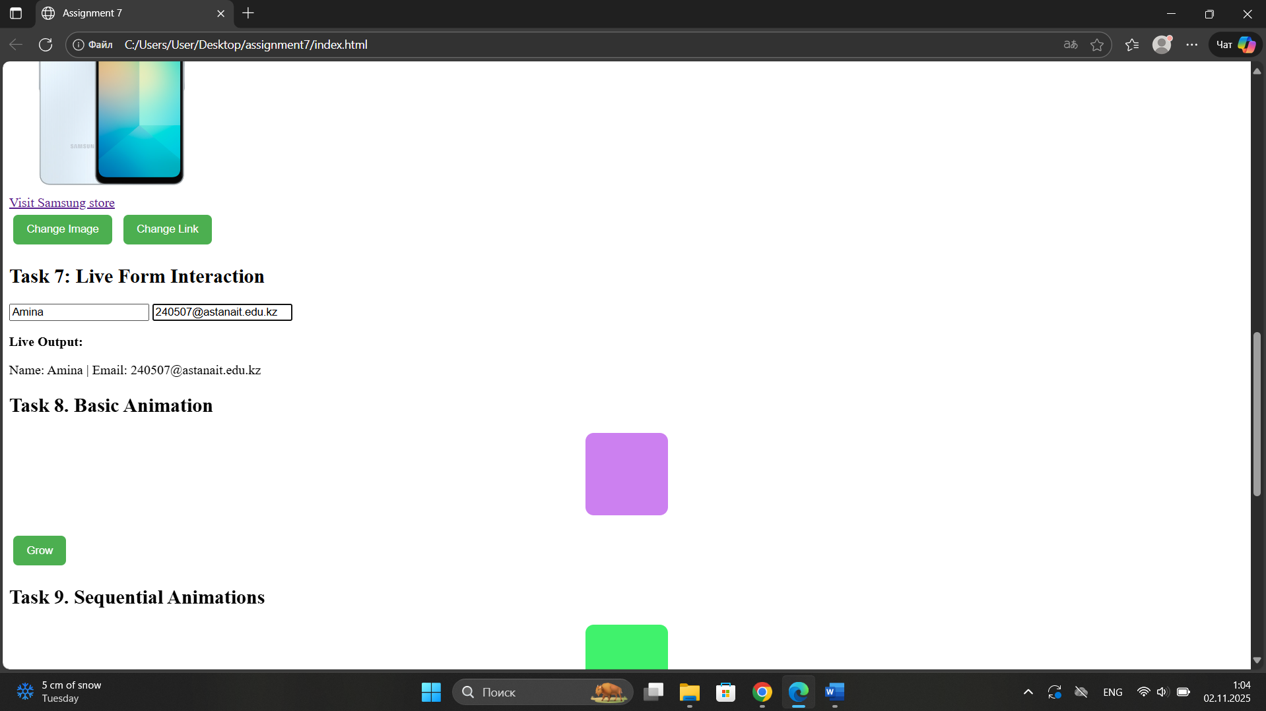

Part 4 – jQuery Animations

Task 8 – Basic Animation
I added a square <div> and a button to animate it using .animate(). When clicked, the box grows in size and moves to the right.
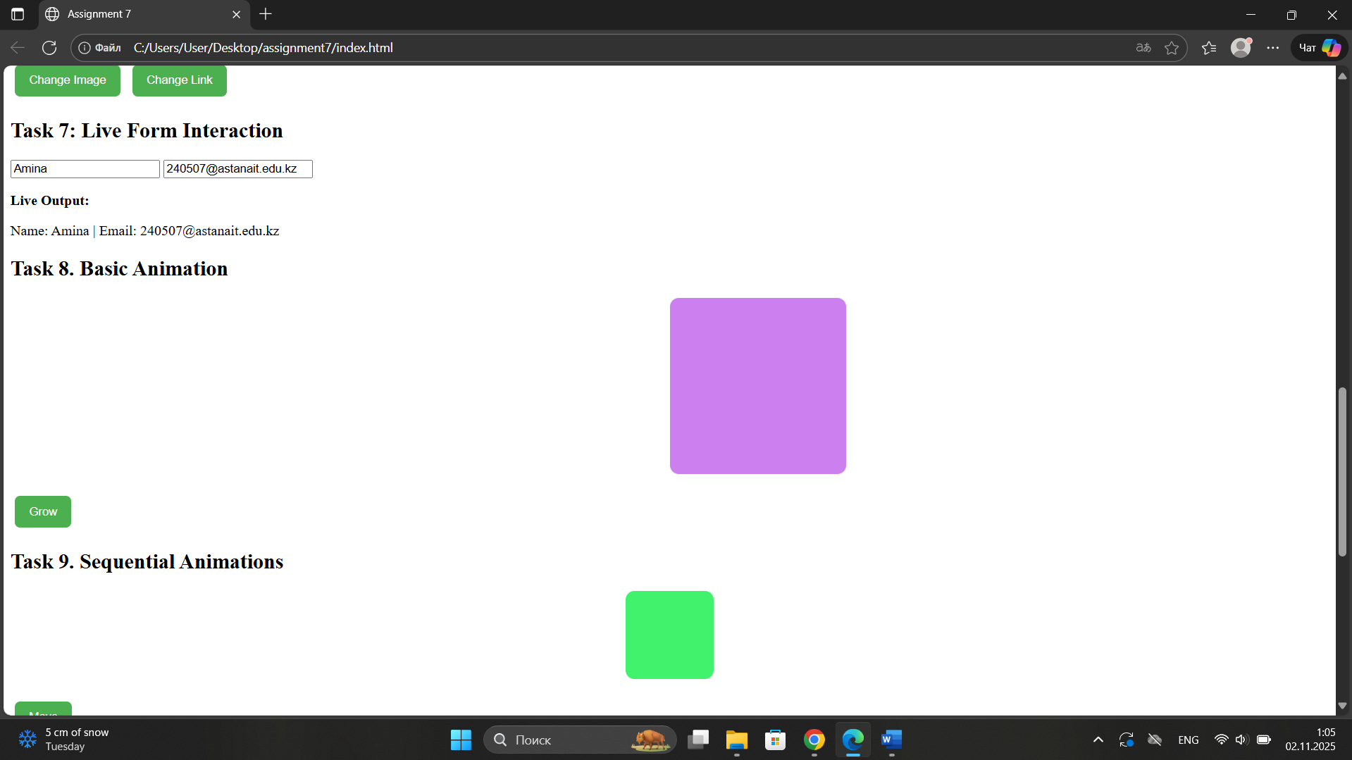

Task 9 – Sequential Animations
I used chained .animate() calls to move another box step by step: right, down, shrink, return to start. This shows how animations can run in sequence using jQuery.
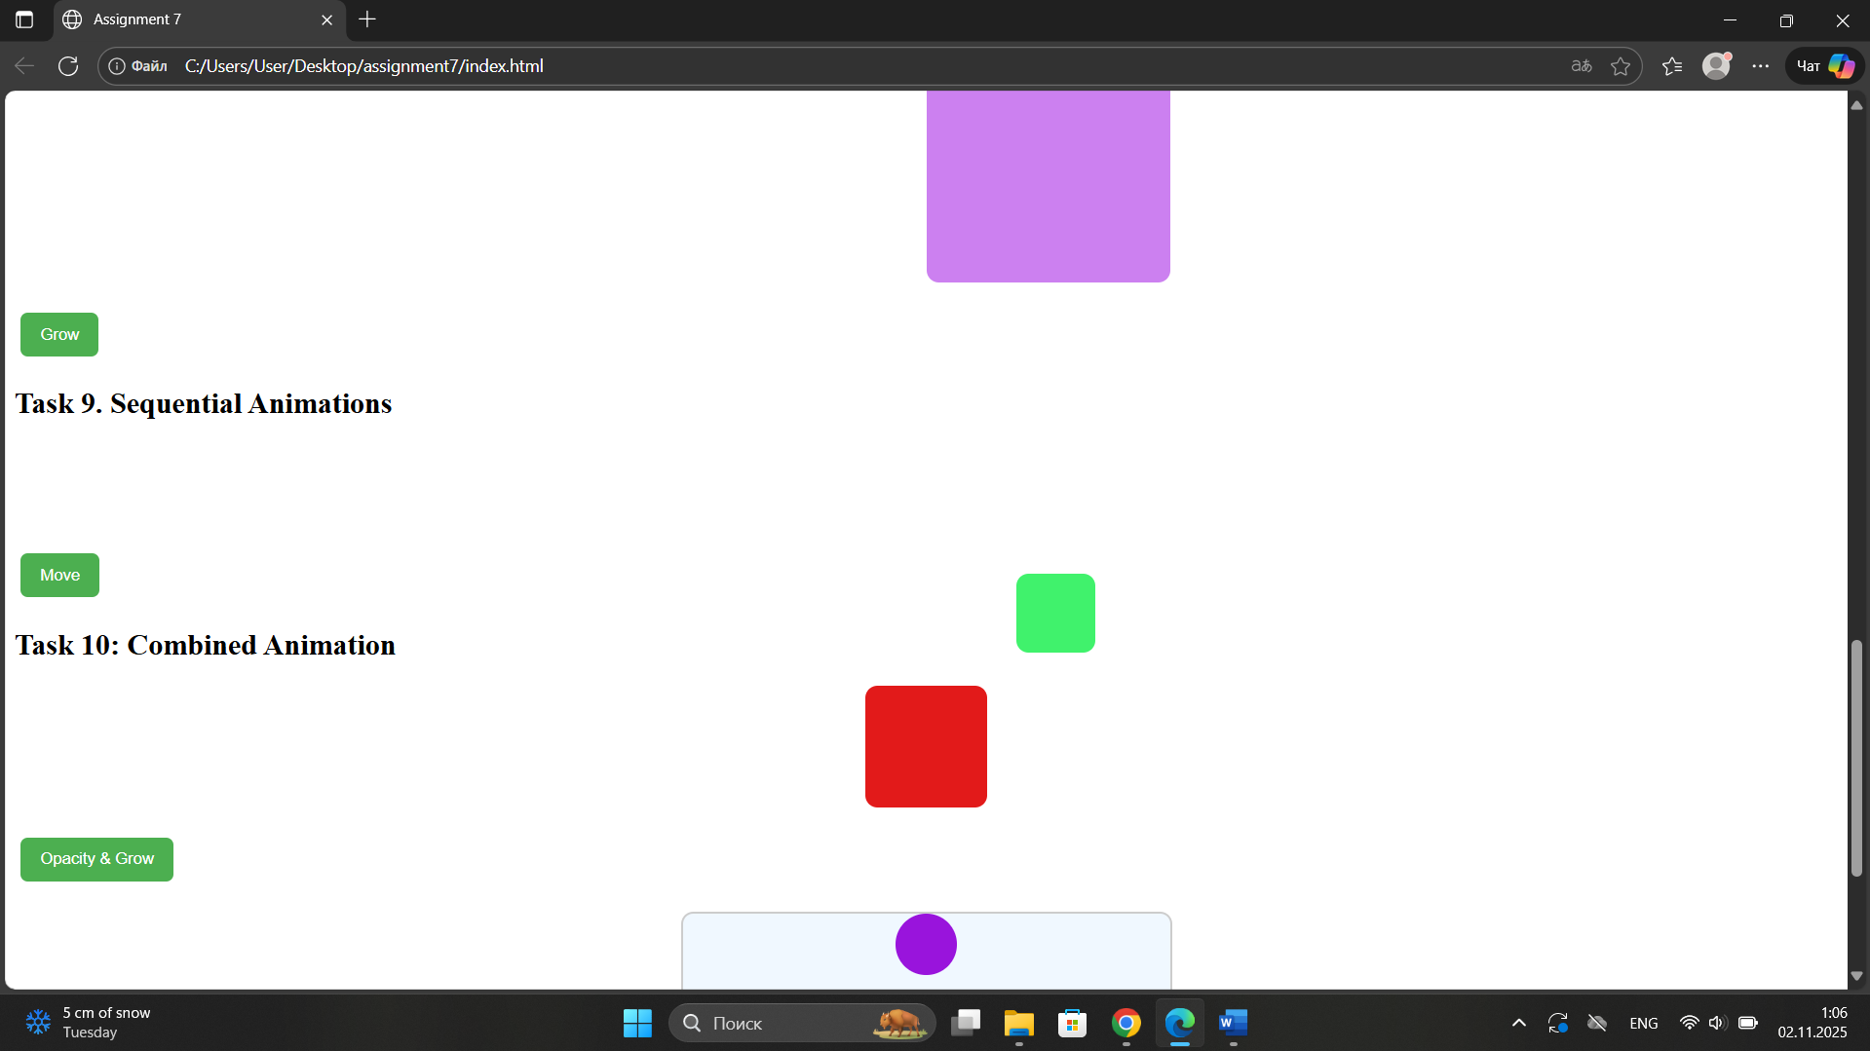

Task 10 – Combined Animation
I made one .animate() call that changes opacity, size, and position together. This creates a combined animation effect that looks really smooth.
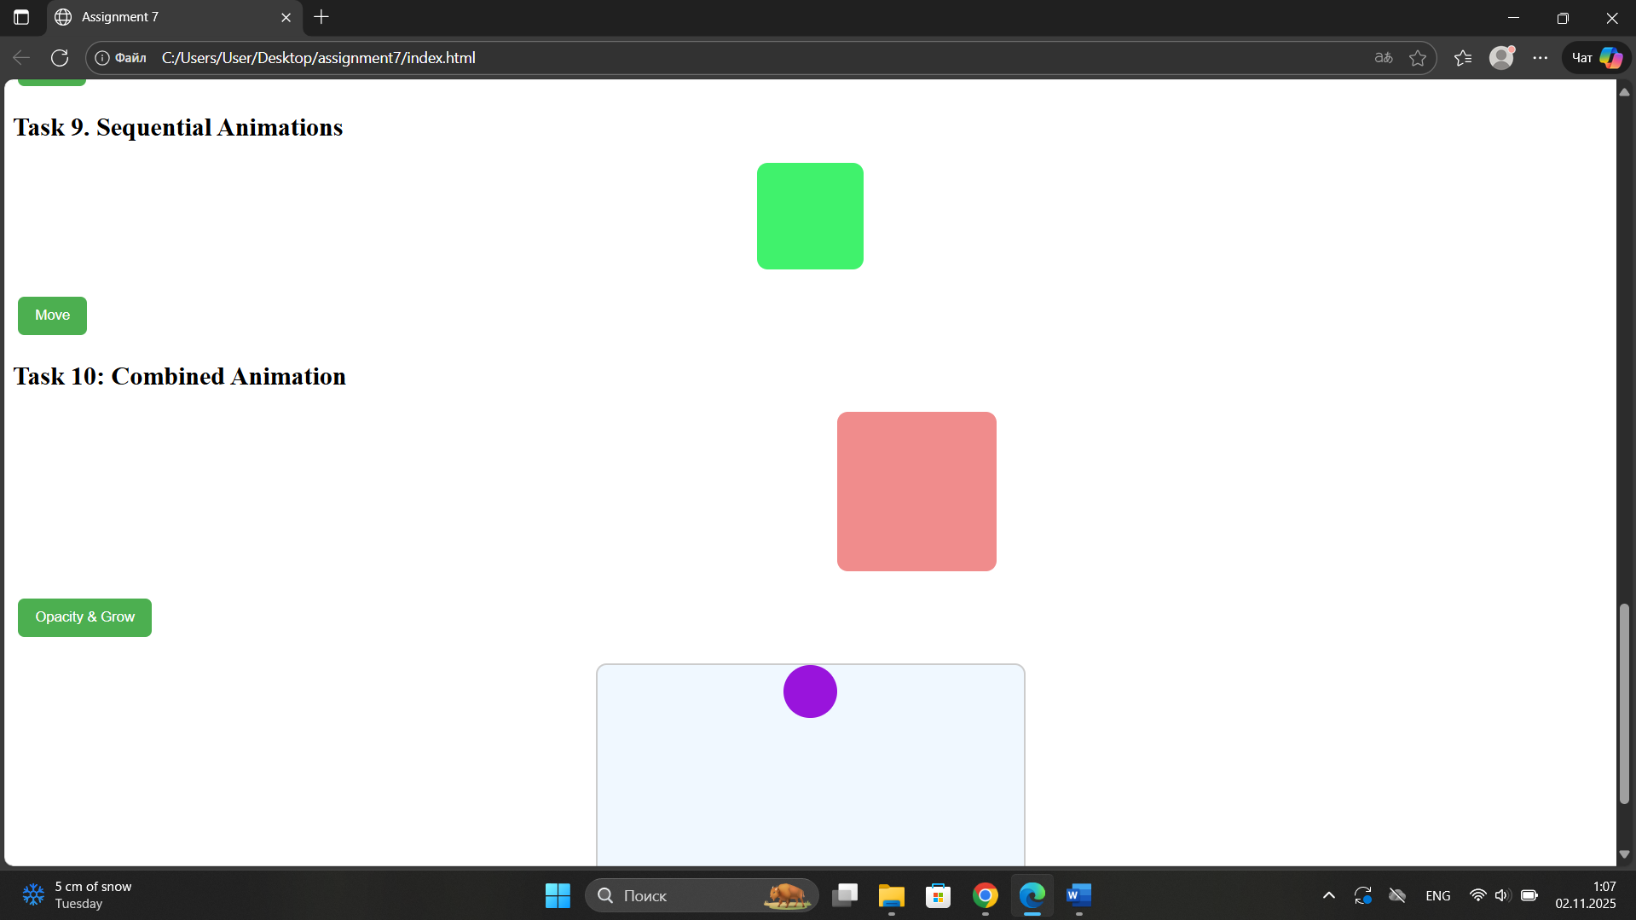

Part 5 – Mini Project: Bouncing Ball

Task 11. Interactive jQuery Project
I created a simple interactive Bouncing Ball animation using only jQuery and inline CSS. When I click Start Bounce, the red ball moves up and down using a recursive .animate() function. When I click Stop Bounce, the ball stops.
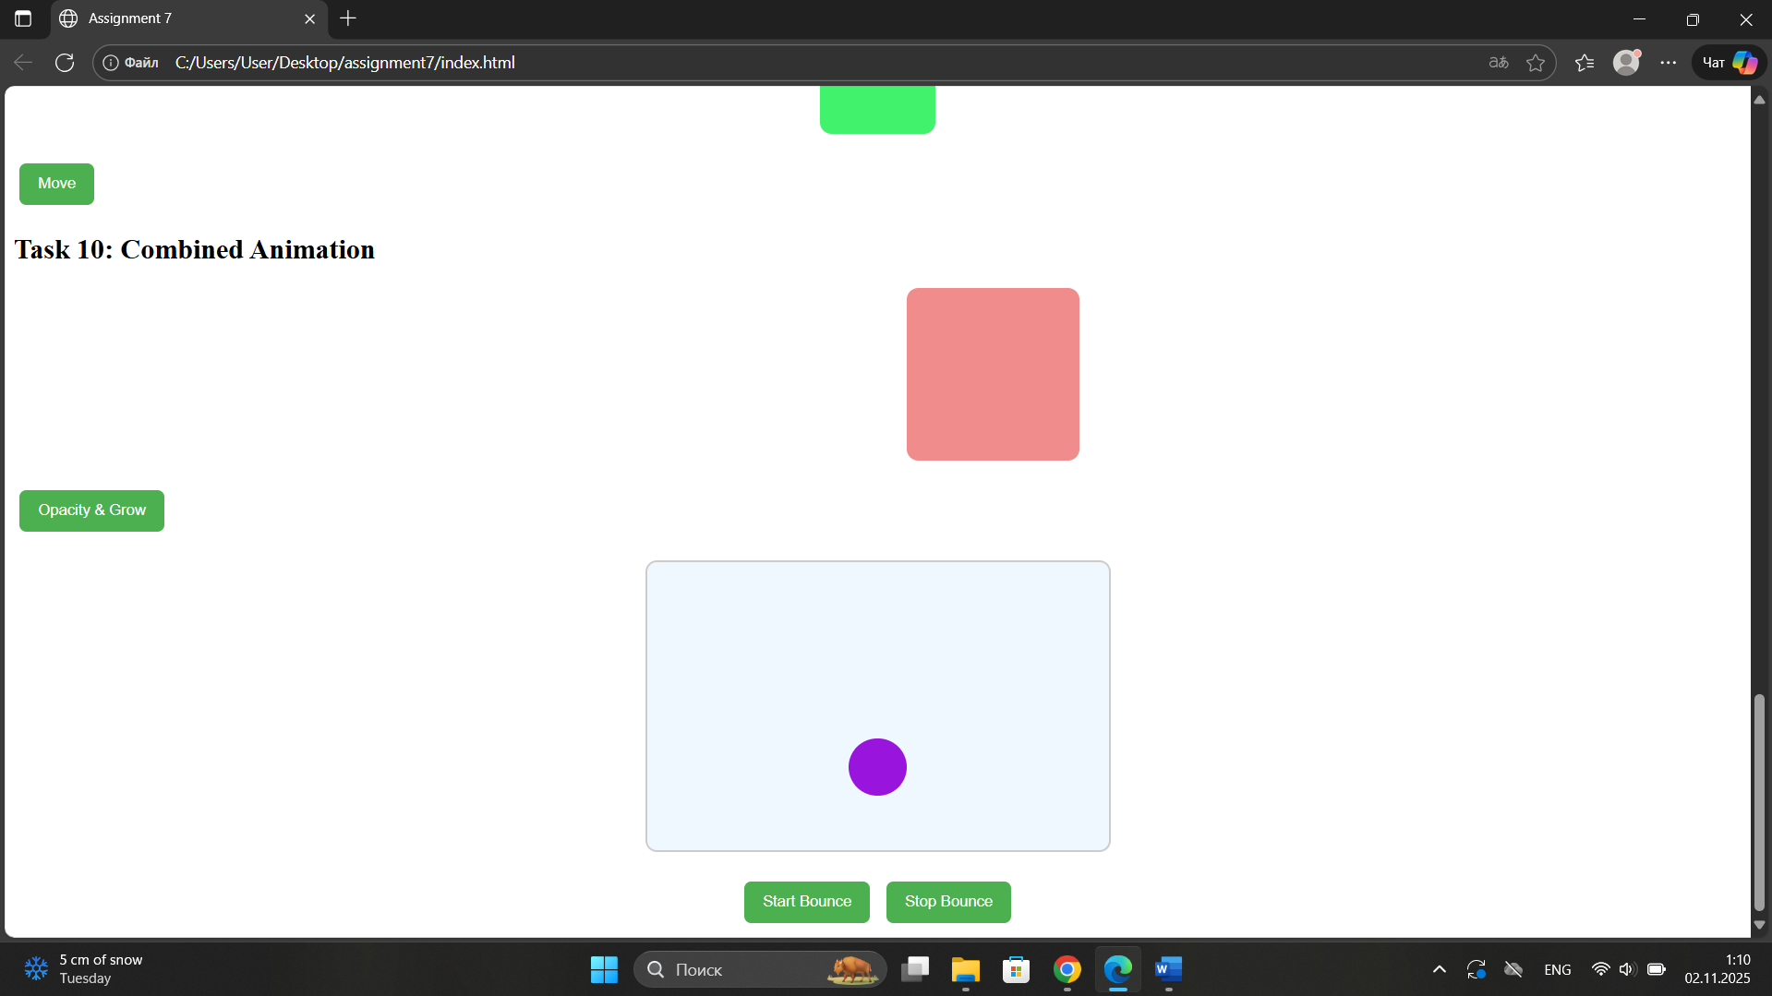

Summary
Through this assignment, I learned how to use jQuery to make webpages interactive and dynamic. I practiced: selecting and styling elements with selectors, .text(), .html(), and .css(), using effects like hide, fade, and slide, manipulating the DOM by adding and removing elements and changing attributes, creating animations using .animate(), and even making a mini project that has animations and event control. Overall, this work helped me understand how jQuery simplifies JavaScript code and adds smooth visual effects with very less code.

